Multiplication theorem (gamma function)

Def

Generalization

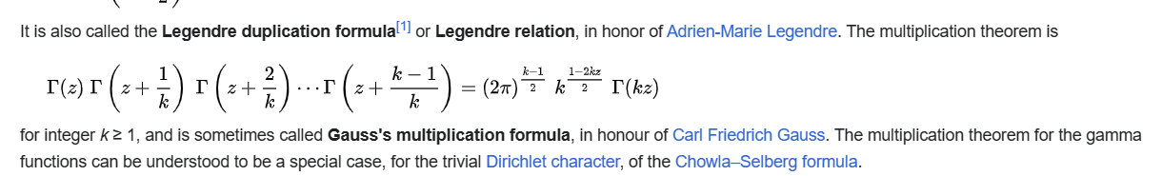

Proof:

Ref

[Multiplication theorem - Wikipedia](https://en.wikipedia.org/wiki/Multiplication_theorem)